Foundations of robotics – Localisation

Robot localisation is the problem of estimating the current position
of the robot, given a map of its world
● Odometry is useful for small movements, but becomes quickly
unreliable as the robot travels longer distances
● GNSS is not good in many cases (e.g. indoor, under metallic
structures)
● The robot’s position can be corrected by
observing landmarks in known locations
● We will see landmark-based localisation

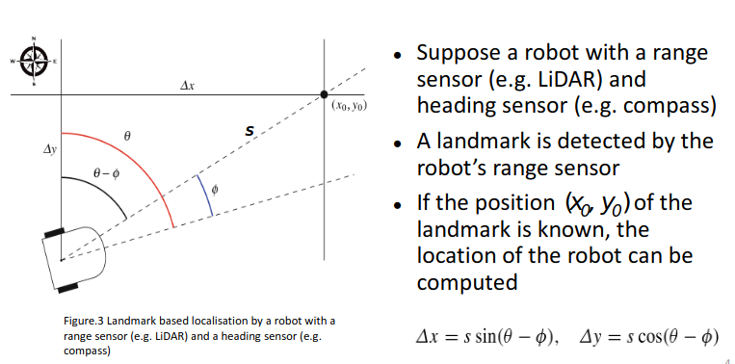
Position from Angle and Distance
Position by Triangulation
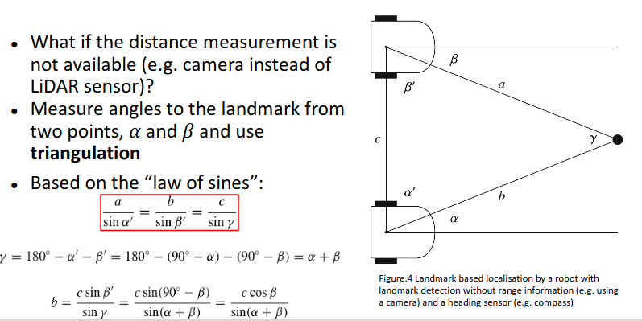
Probability (Markov) Localisation

Let’s assume a robot moving along a corridor and detecting doors
and walls
● The location of doors and walls is known (map) but not the robot’s
location
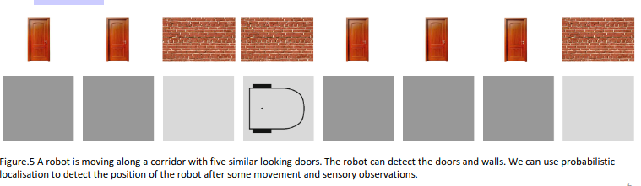
Perfect Sensing and Perfect Motion
